Aim: The objective of this task is to integrate ChatGPT, a conversational AI model, into an AWS infrastructure using Amazon API Gateway and AWS Lambda. Participants will learn how to create an API endpoint that interacts with ChatGPT for handling user queries and responses. AWS Lambda Function.

* Integrating ChatGPT into an AWS infrastructure using Amazon API Gateway and AWS Lambda.

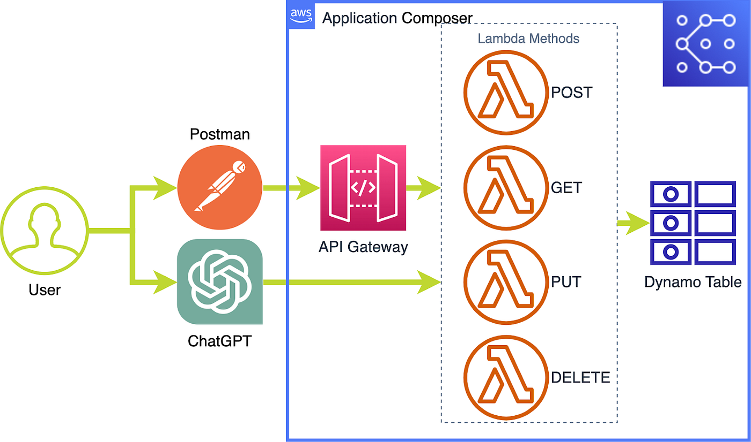

1. Create an AWS Lambda Function:

* Go to the AWS Management Console and navigate to the Lambda service.
* Click on "Create function."
* Choose "Author from scratch."
* Give your function a name and choose the appropriate runtime (Python is commonly used with ChatGPT).
* Create a new role with basic Lambda permissions or choose an existing role with the required permissions.
* Click "Create function."

2. Configure API Gateway:

* Go to the AWS Management Console and navigate to the API Gateway service.
* Click on "Create API."
* Choose "REST API" and click "Build."
* Give your API a name and click "Create API."
* Create a new resource under your API (e.g., "/chat").
* Create a new POST method for the "/chat" resource.
* Configure the integration type to be "Lambda Function" and select the Lambda function you created in Step 1.
* Save the changes.

3. Set up Input and Output for the Lambda Function:

* Define the input format for the Lambda function. For a ChatGPT API, the input might contain the user's message and any additional context.
* Define the output format for the Lambda function. The output should include the response generated by ChatGPT.

4. Handle API Requests in the Lambda Function:

* In the Lambda function code, extract the input data from the API Gateway event.
* Use the input data to query ChatGPT and obtain a response.
* Format the response in the desired output format.
* Return the response to the API Gateway.

5. Deploy the API:

* In the API Gateway console, select the resource and method you created.
* Click on "Actions" and choose "Deploy API."
* Create a new stage (e.g., "prod") and deploy the API.

6. Test the API:

* After deployment, AWS will provide you with an endpoint URL (e.g., https://your-api-id.execute-api.your-region.amazonaws.com/prod/chat).
* You can use tools like `curl` or Postman to test the API by sending POST requests with user messages as input.

7. Monitoring and Scaling:

* Monitor the usage of your API using Amazon CloudWatch logs and metrics.
* If your API experiences high traffic or you need to handle more requests, consider using AWS Auto Scaling to automatically adjust the number of Lambda instances.

8. Optional Improvements:

* Add authentication and authorization mechanisms to secure your API.
* Implement error handling to gracefully handle any issues that may arise during API requests.
* Consider using AWS Parameter Store or Secrets Manager to store sensitive data, like API keys or other configurations.
* Exploring AWS Lambda Function

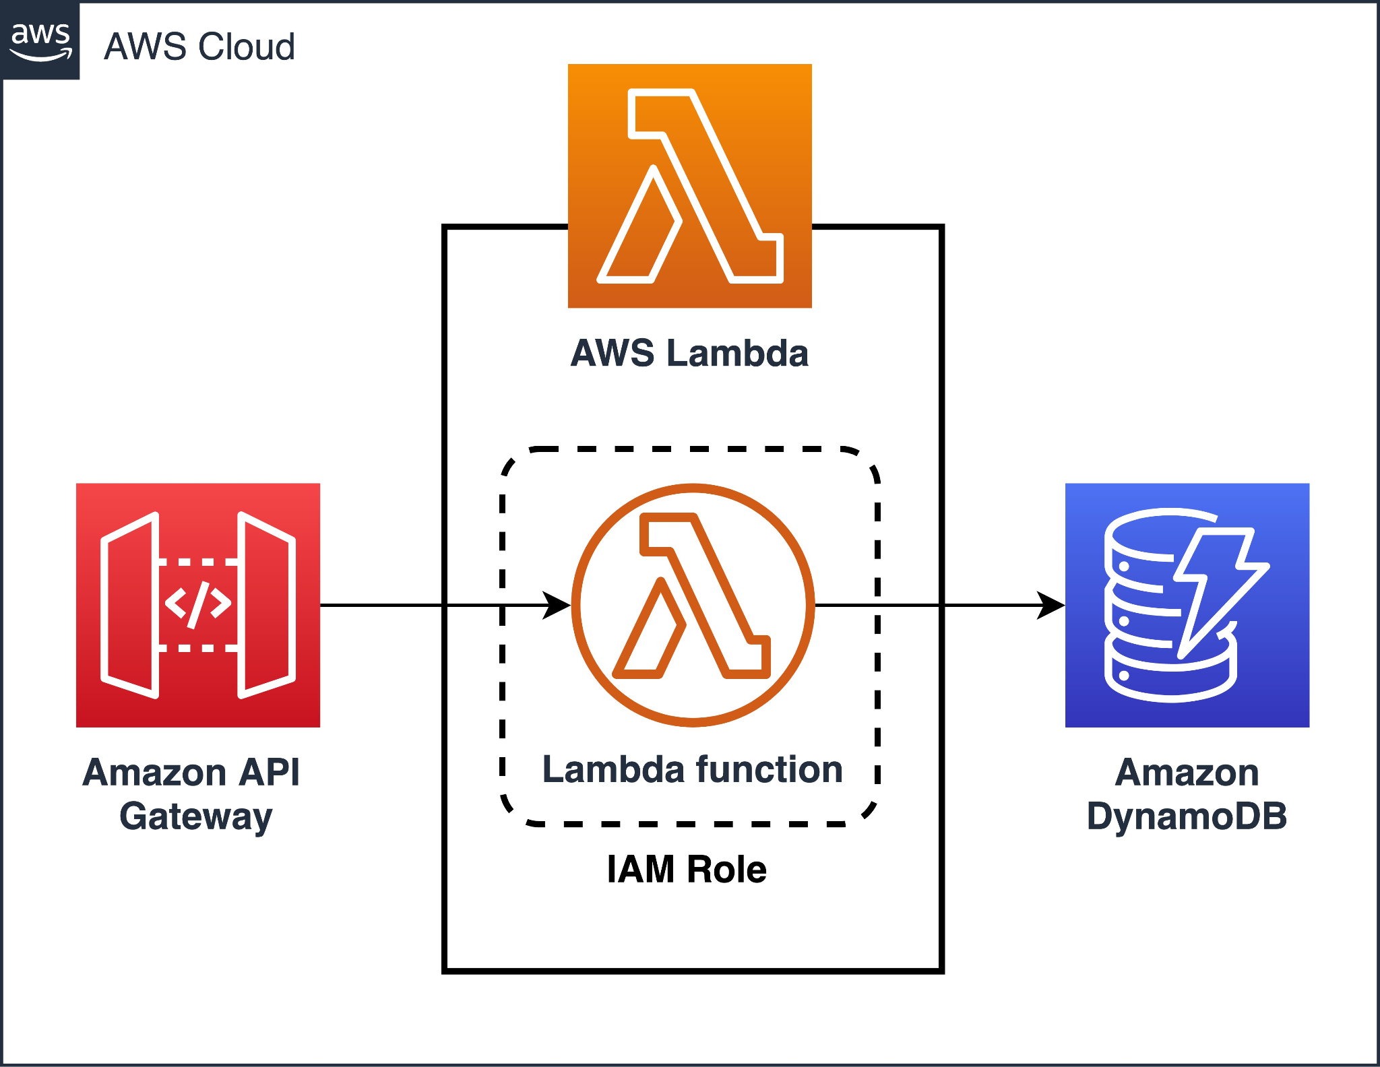

* AWS Lambda is a serverless compute service provided by Amazon Web Services (AWS). It allows you to run code without managing servers, automatically scaling to handle incoming traffic, and billing you only for the compute time you consume. Lambda is commonly used for event-driven architectures and building serverless applications.

Key features of AWS Lambda Function:

1.Trigger-Based Execution: AWS Lambda is designed to execute code in response to specific events. These events can be generated from various sources like API Gateway, S3 buckets, DynamoDB tables, CloudWatch events, and more. When an event occurs, Lambda automatically triggers the execution of the associated function.

2.Supported Runtimes: Lambda supports multiple programming languages, including Node.js, Python, Ruby, Java, Go, .NET Core, and custom runtime environments.

3.Function Code: You upload your function code as a deployment package. This package can include any necessary libraries and dependencies. AWS Lambda takes care of provisioning the execution environment and managing the underlying infrastructure.

4.Execution Environment: Each Lambda function runs in its isolated execution environment, which allows the function to be stateless. AWS manages this environment, and it is automatically scaled up or down based on incoming requests.

5.Concurrent Execution: Lambda automatically scales the number of concurrent executions based on incoming traffic, ensuring high availability and efficient resource utilization.

6.Configuration and Environment Variables: You can configure various settings for your Lambda function, such as memory allocation, timeout, and environment variables. Environment variables can hold sensitive data, configuration parameters, or connection strings.

7.Logging and Monitoring: AWS Lambda automatically captures logs, which you can view using Amazon CloudWatch. This enables you to monitor the function's performance, troubleshoot issues, and set up alarms for specific events.

8.Versioning and Aliases: Lambda allows you to create multiple versions of your function code and assign aliases to these versions. This helps in managing different stages (e.g., development, production) and allows you to easily switch between versions without updating the API Gateway or other event configurations.

9.Integration with Other AWS Services: Lambda can be integrated with various AWS services, making it an integral part of a serverless architecture. It plays well with services like API Gateway, S3, DynamoDB, Step Functions, and more.

10.Security and IAM: AWS Lambda leverages AWS Identity and Access Management (IAM) for access control, allowing you to define who can invoke specific functions and access associated resources.

11.Cost Optimization: One of the significant advantages of Lambda is that you only pay for the compute time your code consumes, measured in milliseconds. This serverless pricing model can lead to cost savings, especially for sporadic workloads or applications with varying traffic patterns.

* How API Gateway works

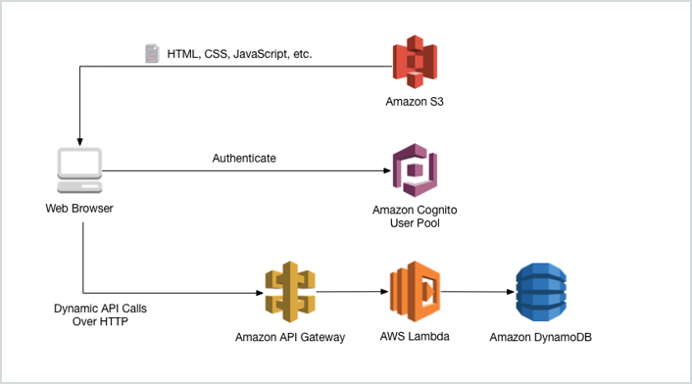

* API Creation: In AWS API Gateway, you start by creating a new API. This API will act as the front-end for your application, defining the endpoints and methods that clients can use to interact with your back-end services.
* Resource and Method Setup: Within the API, you define resources, which represent the paths of your API (e.g., "/users", "/products"). Each resource can have multiple methods (e.g., GET, POST, PUT, DELETE), which correspond to the HTTP verbs used for interactions.
* Integration with AWS Lambda: For a specific resource and method, you can set up an integration with an AWS Lambda function. This means that when a request is made to that endpoint, API Gateway will invoke the corresponding Lambda function.
* Request and Response Mapping: Before invoking the Lambda function, API Gateway can perform request and response mapping, allowing you to transform the data between the incoming HTTP request and the event format expected by the Lambda function. Similarly, the response from the Lambda function can be transformed before it's sent back to the client.
* Request Validation: API Gateway can validate incoming requests based on defined models or schemas. This helps ensure that clients provide the required data in the correct format before the request is forwarded to the Lambda function.
* Security and Authentication: API Gateway offers various security mechanisms to control access to your API. You can set up API keys, IAM roles, or integrate with Cognito user pools to authenticate and authorize users before they can access specific resources.
* Throttling and Rate Limiting: API Gateway allows you to set throttling and rate limits to control the number of requests clients can make within a specific time period. This helps prevent abuse and ensures fair usage of your API.
* Monitoring and Logging: API Gateway provides detailed monitoring and logging capabilities through integration with CloudWatch. You can monitor API usage, view logs, and set up alarms for specific metrics.
* API Deployment: Once you have configured your API, you can deploy it to a specific stage, such as "prod" for production or "dev" for development. Each stage represents a snapshot of your API configuration, and you can have multiple stages to support different environments.
* Custom Domain and SSL: API Gateway allows you to set up a custom domain for your API, providing a more user-friendly URL for clients. You can also enable SSL certificates to secure the communication between clients and API Gateway.
* Scaling and High Availability: API Gateway automatically scales to handle incoming traffic, ensuring high availability and performance. It can handle a large number of concurrent requests and automatically manages the underlying infrastructure.
* Reflect on the benefits and challenges of integrating ChatGPT in AWS using API Gateway and Lambda.

Benefits

1.Scalability: AWS Lambda automatically scales based on incoming requests, allowing you to handle varying levels of traffic without managing infrastructure. This scalability is crucial for accommodating fluctuations in user demand when using a resource-intensive AI model like ChatGPT.

2.Cost-Effectiveness: With Lambda, you pay only for the compute time your function uses, which can lead to cost savings compared to traditional server-based architectures. You're not charged for idle time, making it an efficient choice for handling sporadic user interactions.

3.Managed Service: AWS API Gateway and Lambda are fully managed services. AWS takes care of the underlying infrastructure, security, and availability, freeing you from the burden of server management and allowing you to focus on building the application logic.

4.Event-Driven Architecture: API Gateway allows you to trigger Lambda functions based on specific events, such as HTTP requests. This event-driven approach is well-suited for conversational AI scenarios, where the Lambda function can be invoked in response to user queries.

5.Security: API Gateway provides authentication and authorization mechanisms to secure access to your API, protecting your ChatGPT model from unauthorized usage. Lambda can be integrated with IAM roles, allowing you to control which resources the function can access.

Challenges:

1.Cold Start Latency: AWS Lambda functions may experience cold starts when they are not used for a while, resulting in slightly higher latency for the first request. For real-time interactions like chat applications, this initial delay may be noticeable to users.

2.API Gateway Limits: API Gateway has rate limits and throttling policies, which could potentially impact API availability if the API experiences a sudden spike in traffic. Careful monitoring and setting appropriate limits are necessary to handle such scenarios.

3.Payload Size: ChatGPT responses can be quite large, especially for long and detailed conversations. API Gateway has payload size limits, and large responses may need to be truncated or split to fit within these limits.

4.State Management: As AWS Lambda functions are stateless, maintaining context across multiple requests for an ongoing conversation requires additional effort. You may need to integrate with external services (e.g., DynamoDB, Redis) to store and retrieve conversation history or context.

5.API Monitoring and Scaling: Ensuring the performance of the ChatGPT API requires monitoring the Lambda function's usage, considering possible bottlenecks, and adjusting concurrency limits and function configuration accordingly.

6.ChatGPT Costs: Although Lambda's pricing model is cost-effective for compute time, you should be aware of potential costs associated with the usage of ChatGPT itself. AI models like ChatGPT may involve additional expenses based on usage and the subscription model you've chosen.

* Discuss potential use cases for this integration, such as chatbots, customer support, or natural language interfaces.
* The integration of ChatGPT with AWS API Gateway and Lambda opens up a wide range of potential use cases, leveraging the power of natural language processing and AI-driven conversations. Here are some prominent use cases where this integration can be applied:

1.Chatbots and Virtual Assistants: Deploying ChatGPT as a chatbot allows organizations to provide interactive and human-like conversations with users. It can assist users in various tasks, answer questions, and provide recommendations, enhancing customer engagement and user experience.

2.Customer Support and Helpdesk: ChatGPT can be integrated into customer support systems to handle customer queries and provide personalized assistance. It can help customers troubleshoot issues, access account information, and guide them through common tasks.

3.Language Translation and Transcription: By integrating ChatGPT with language translation services, you can create a powerful multilingual interface that translates text or speech in real-time, enabling seamless communication across language barriers.

4.Content Creation and Summarization: ChatGPT can be used to generate content for blog posts, articles, or product descriptions. It can also summarize lengthy documents, providing concise and digestible information.

5.E-commerce Recommendations: By integrating ChatGPT with an e-commerce platform, you can create a personalized shopping experience. ChatGPT can recommend products based on user preferences and browsing history.

6.Interactive Learning and Training: ChatGPT can serve as an interactive tutor or virtual instructor, answering questions and providing explanations in educational applications.

7.Interactive Gaming: ChatGPT can enhance gaming experiences by acting as an in-game character, providing hints, or even creating dynamic narratives based on player interactions.

8.Automated Surveys and Feedback Collection: ChatGPT can conduct surveys and collect feedback from users, providing a conversational and user-friendly experience.

9.Healthcare and Medical Support: In healthcare applications, ChatGPT can offer information on symptoms, medical conditions, and first-aid tips. It can also schedule appointments or offer guidance in non-critical situations.

10.Personal Assistants and Productivity Tools: ChatGPT can serve as a personal assistant, helping users manage their schedules, set reminders, and organize tasks.

11.Travel and Tourism Assistance: By integrating with travel-related services, ChatGPT can assist travelers with trip planning, destination information, and recommendations.

12.Interactive Storytelling and Entertainment: ChatGPT can be used to create interactive storytelling experiences or engaging chat-based games.

The potential use cases are virtually limitless, limited only by the creativity and specific needs of the applications. By integrating ChatGPT with AWS API Gateway and Lambda, developers can build powerful, AI-driven conversational interfaces that deliver value across various domains, improve user engagement, and enhance the overall user experience.